A. SIGNIFICANCE
A.1. Global and domestic tuberculosis (TB) prevention is backsliding. Following years of consistent reductions in TB incidence and encouraging trends toward global TB control targets, global TB incidence has increased each year since 2020. In 2023, 8.2 million people were newly diagnosed with TB, representing the largest number of TB cases ever documented since global reporting began in 1995. An estimated 1.25 million people died from TB in 2023, and TB is currently the leading cause of death from any single infectious agent. ¹ In the U.S., TB cases have surged, with >10,000 TB cases reported in 2024, marking an 8% increase from 2023 and the highest number since 2011. ²

A.2. Global TB prevention efforts protect public health and health security in the U.S. Mathematical modeling studies suggest that without continued reductions in the global burden of Mtb infections, TB elimination in the U.S. will be impossible. ³ A large, recent TB outbreak in Kansas underscores the need for continued investment in TB prevention and research both in the U.S. and globally. ⁴ Supporting public health work and scientific research to tackle TB epidemics outside the U.S. is a strategic investment in U.S. domestic health security and a necessary step towards renewing progress toward TB elimination in the U.S.

A.3. Existing diagnostics for Mtb infection poorly predict progression to disease and cannot differentiate recent from persistent infection. Existing diagnostics, including tuberculin skin testing (TST) and interferon gamma release assays (IGRA), detect immunological signatures of Mtb infection that persist over time and are unable to differentiate persistent from more recent Mtb infection. Importantly, only 5-10% of those with IGRA- or TST-verified Mtb infection will develop TB (i.e. the clinical disease resulting from Mtb infection) in their lifetime ⁵, so existing tests for Mtb infection are poorly predictive of future progression to active TB. ^{6,7} Likewise, because IGRA and TST reflect Mtb exposure across a person’s lifetime, infection prevalence estimates based on these diagnostics capture long-term historical trends in TB epidemiology but fail to reflect the current risk of infection.

A.4. Gaps in diagnostic capabilities have delayed advancements in TB vaccine development. Safe and effective vaccines for TB would transform global TB prevention efforts, but their development has been painstakingly slow. According to the World Health Organization, a moderately effective TB vaccine for adults and adolescents could cumulatively avert 37.2–76.0 million cases and 4.6–8.5 million deaths before 2050. ⁸ However, the endpoint in such trials (incident TB) is rare, even in high TB-burden contexts, so a major obstacle for advancing candidate vaccines is the large size and extended duration of late-stage TB vaccine trials. To address this challenge, trial sites must be carefully selected to ensure a sufficiently high rate of Mtb infection, and TB burden, to reach the required number of clinical TB endpoints. The process of selecting trial locations typically employs large observational studies that measure Mtb infection prevalence, as a marker of transmission intensity, with IGRA. Because 10-15% of positive IGRA responses revert to negative each year, ⁹ estimates of the annual risk of Mtb infection using IGRA prevalence can underestimate the true annual risk of infection by a factor of 5–10. ¹⁰,¹¹ Incorrectly estimating the risk of Mtb infection using IGRA makes it difficult to rank possible sites by transmission intensity and could ultimately lead to unsuccessful trials. To ensure the accrual of a sufficient number of endpoints, most trials selectively enroll participants who are already Mtb-infected (IGRA-positive) and therefore more likely to develop TB than IGRA-negative persons. However, because progression rates among IGRA-positive individuals remain low ¹², trials using IGRA-selective recruitment still require large sample sizes and prolonged follow-up periods. ¹³ For example, the ongoing Phase 3 trial of M72-AS01_{e}, a promising candidate vaccine, will enroll >20,000 participants with Mtb infection and follow them for three years.

We propose that new diagnostics could (A) better measure transmission intensity in candidate vaccine trial sites and (B) identify participants most likely to progress to TB, reducing both the size and duration of these trials and accelerating the evaluation and successful delivery of an effective vaccine for TB.

A.5. Tools for tracking recent changes in Mtb infection rates are lacking, slowing the evaluation and implementation of new TB control strategies. Continued progress toward TB elimination depends on our ability to curb TB transmission.²⁰ Evaluating new interventions which aim to reduce transmission typically relies on measuring changes in the incidence of TB cases. However, this approach suffers from two problems: First, Mtb transmission can occur months or years before a resultant clinical case of TB develops, is diagnosed, and is reported; thus, TB case report data severely lags behind infection incidence. Second, up to 50% of all TB cases globally may go undiagnosed. ^{14–1617} As a result, approaches that rely only on reported TB cases are a poor indicator of real-time epidemiologic conditions. This shortcoming leaves important scientific work and public health efforts, including those focused on disrupting TB transmission, without a reliable, informative tool for measuring timely year-to-year changes in Mtb infection rates. This critical gap in diagnostic capabilities has important implications for studies evaluating the impact of innovative TB control strategies, which, like TB vaccine studies, still require large sample sizes and extended follow-up durations. For example, the ZAMSTAR study, which examined the impact of intensified household-level interventions for HIV and TB, involved over 64,000 participants and a four-year follow-up period. ¹⁸

Diagnostic assays that can enable tracking of year-to-year trajectories in Mtb transmission would have wide-reaching benefits for the design and evaluation of new interventions for disrupting Mtb transmission, with follow-on impacts in TB prevention and care.

A6. Diagnostic biomarkers for recent Mtb infection, currently under development and in validation testing, offer a potentially paradigm-shifting tool for TB science. There are at least four biomarker-based strategies for identifying recent Mtb infection to date, at different stages of development and evaluation. ¹⁹ Among these candidate strategies, methods based on Mtb-specific T-cell activation in peripheral blood (‘TB-TASA’) have undergone the most extensive evaluation, with promising results from early validation studies (see preliminary data, section A.9.1). Further research and investment is needed to evaluate both TB-TASA and other platforms, with the goal of advancing translation of these tools both for clinical use and for innovative and potentially transformative use cases in TB research and public health programs.

A7. Target test performance characteristics vary across different use cases. The WHO has defined target test performance attributes (‘Preferred Product Characteristics’) for multiple kinds of TB diagnostics. However, target profiles present one set of ideal test characteristics, which may not be suitable for all applications or epidemiologic contexts in which the test may be used. Examining test sensitivity and specificity highlights how target product profiles can differ widely by application: Using a test to screen for eligibility in a vaccine trial requires high specificity to avoid misclassification of persistent Mtb infections as recent, which would yield fewer incident TB cases and could result in an unsuccessful trial. Likewise, low specificity and a high false positive rate could overestimate recent Mtb transmission intensity, making it difficult to reliably identify trials sites with sufficiently high TB burden. Using the same high specificity test in a clinical context (for example, to prioritize individuals for preventive therapy) could yield an unacceptable number of false negatives. In addition, time to positivity (TTP, how quickly after infection a person tests positive) and duration of positivity (DOP, time from initial positivity to reversion) (Figure 1) will also influence the utility of a test across different applications. Evaluating trends in transmission intensity requires a sufficiently short TTP to minimize delays in detection. The DOP must be sufficiently long to ensure that it can detect enough infections to produce reliable estimates of infection incidence, but short enough to offer a reasonably precise indication of infection time. Specifying the requisite ranges for test characteristics (e.g., sensitivity, sensitivity) and the potential tradeoffs (e.g., a short vs. long DOP) for specific applications can identify those for which a given test will be maximally useful.
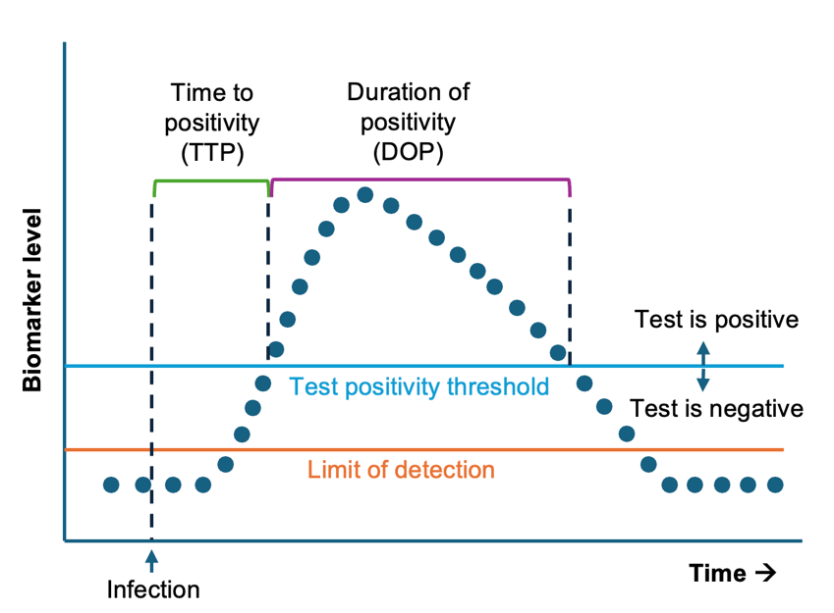
Figure 1. Sensitivity, specificity, time to positivity (TTP, time from infection to initial positivity) and duration of positivity (DOP, time from initial positivity to reversion) will influence the utility of a test for a specific use-case.

A8. Mathematical modeling can deliver critical insights at this juncture of biomarker development, providing guidance on the most promising applications for tests of recent Mtb infection. Mathematical modeling enables rapid, reproducible simulations that can evaluate how a given test, with given performance characteristics, applied across different epidemiological contexts (e.g., high versus low TB transmission), will deliver on specific public health goals. Importantly, even if a test meets the minimum performance characteristics for a specific use-case, designing an optimal implementation plan will depend on the epidemiologic context. The population age distribution, true rate of Mtb infection, and other factors such as HIV prevalence may influence the utility of a test for recent Mtb infection. Moreover, mathematical modeling can highlight how uncertainty in test characteristics (e.g., the TTP or DOP) limits our ability to predict how a test will perform in a given epidemiologic setting, thus providing rationale for targeted observational studies to more precisely measure these test characteristics. These findings can then be used to guide future studies on tests like TB-TASA, focusing research effort into validation studies that will accelerate their translation into high-impact applications.

A.9. Preliminary data. Data on the performance of TB-TASA from observational studies and preliminary outputs from mathematical models developed by our team support the premise of our proposal and demonstrate our ability of to successfully deliver on its objectives.

A.9.1 TB-TASA is an innovative diagnostic that can differentiate recent from persistent Mtb infection. TB-TASA is an immune-cell based diagnostic that measures the relative activation of Mtb-specific T cells, a biomarker that directly responds to within-host Mtb antigen load and bacillary burden. Mtb bacillary burden and antigen load are expected to be higher during early Mtb infection and progression to disease, and lower or absent after cure via anti-TB therapy or clearance of infection. TB-TASA identifies Mtb-specific T cells by detecting intracellular IFNγ and TNF expression following stimulation with Mtb-specific antigens (e.g., ESAT-6 and CFP-10) and determines the level of activation in the Mtb-specific T cell population. ^{20–22} The readout of TB-TASA is the proportion of HLA-DR+ Mtb-specific T cells measured by flow cytometry. Published ²³ and more recent unpublished data (Figure 2) shows discrimination between persistent and recent Mtb infection among adolescents and children in a household contact study, measured using the QuantiFERON (QFT) assay, a type of IGRA.⁹ Adolescents and children who converted from QFT- to QFT+ within the past 6 months (reflecting recent Mtb infection) had significantly higher TB-TASA readouts than those with pre-existing QFT+ (reflecting persistent Mtb infection). In adolescents, the sensitivity and specificity for differentiating recent from persistent Mtb infection in those with detectable ESAT-6 and CFP-10 T cell responses were 61% and 83%, respectively (ROC: 0.74); in the household contact study, sensitivity and specificity were 91% and 67%, respectively (ROC: 0.85). Although this preliminary data is promising, the performance of TB-TASA in older individuals who are less likely to have a primary Mtb infection, in settings with high transmission intensity where many infections are expected to be reinfections, and among persons living with HIV who mount weaker responses to the antigens in IGRAs, remain important potential sources of variability in TB-TASA performance. We will directly address these uncertainties in our proposal.
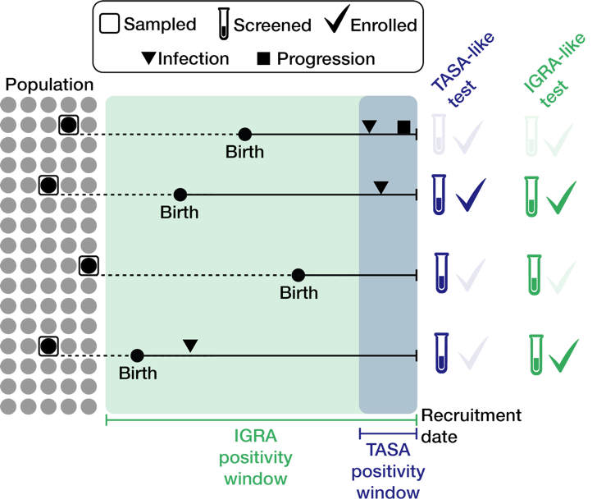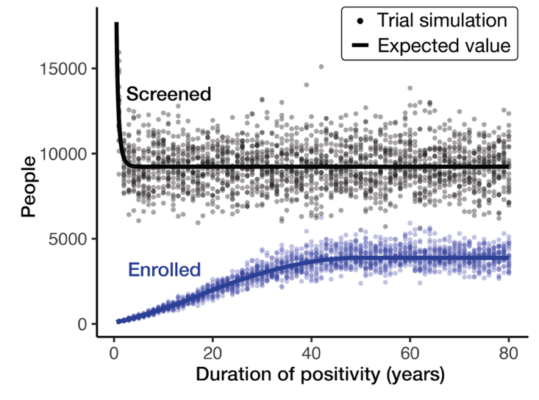Figure 3. Model schematic and preliminary trial simulation results. (Left panel) Illustration of the vaccine trial simulation model. Individuals are sampled randomly from a synthetic population (grey circles). Infection trajectories, consisting of the timing of infection and active TB progression (triangles, squares) are simulated for each person. Sampled individuals without active TB are screened using a diagnostic test with a given DOP (positivity window). Those who test positive (i.e., whose infection occurred within the test’s positivity window) are enrolled. Model outputs are the number of people sampled, screened, and enrolled for a test with a given DOP. (Right) Screening (black) and recruitment (blue) numbers for 2,000 simulated vaccine trials. Simulations use screening tests with DOP ranging from months (TB-TASA-like) to years (IGRA-like).

Figure 2: Evaluation of TB-TASA for differentiating recent versus persistent Mtb infection. TB-TASA scores are significantly higher in adolescents (a) or children who were household contacts (b) with recent QFT conversion (QFT- to QFT+ within 6 months) than in those with persistently positive QFT. Responders are defined by a fishers’ exact test (p < 0.01), and a greater than 3-fold change compared to the negative control (PBS). The dashed line at 10% indicates the threshold for TB-TASA positivity.
A.9.2. Our group has developed a flexible mathematical model that simulates TB vaccine trials with test-selective (TB-TASA, IGRA, or others) recruitment across different epidemiological contexts. This model generates Mtb infection trajectories, simulating the timing of Mtb and progression to active TB, for each member of a synthetic age-structured population. Using this collection of infection trajectories, we can sample individuals according to different strategies (random, age-limited) over a given time period. If an individual does not have TB at the time of sampling (according to their infection trajectory), they are screened using a test with a DOP of k years (months for TB-TASA, years for IGRA). Individuals who test positive according to either test are enrolled and we simulate TB progression for the enrolled cohort over a 3-year trial period. We continue sampling from the community until we enroll N individuals who progress during the trial, where N is a function of the trial’s power. For each simulation, we measure the number of people sampled, screened, and enrolled to reach N progressors. Preliminary results are shown in Figure 3. Vaccine trial size needed to enroll N=50 progressors steadily declines as a test’s DOP shrinks (i.e., from IGRA-like to TB-TASA-like tests) because screening tests with a short DOP helps exclude individuals with persistent Mtb infection. In one scenario, relative to an IGRA-like test, a TB-TASA-like test with a 6-month DOP could yield an expected 32-fold reduction in trial size (121 vs. 3,879 enrolled) with only a 1.9-fold increase in the number screened (17,720 vs. 9,234 screened). A modestly longer DOP (one year) could generate a similar 26-fold expected reduction in trial size (147 enrolled) with a 1.3-fold increase in the number screened (11,982 screened). These findings are based on simplifying assumptions, including a uniform age distribution, constant TB incidence, and perfect test sensitivity/specificity within the test’s positivity window. Nevertheless, this modeling framework provides a strong basis for simulating trials under more realistic conditions.

B. INNOVATION
Our study is innovative in three ways:
- We will leverage innovative methods that can clearly delineate recent and persistent infection using immunological signatures of Mtb antigen-specific T cell activation (TB-TASA). TB-TASA is a novel immune-cell based diagnostic that is one of the first to reliably distinguish between recent and persistent infection. This tool could revolutionize our understanding of TB epidemiology and transmission. Deliverables from our work will also support the future development of other tests for recent Mtb infection (including, for example, transcriptomic-based approaches and assays measuring responses to Mtb dormancy antigens). ^{19,24–26}
- We will expand the use-cases for this assay beyond clinical management of Mtb-exposed persons, to understand the highly impactful breadth of applications of a test for recent Mtb infection. Previous development and validation of this assay have focused on determining eligibility for TB preventive therapy. We propose to explore the potential of this new assay to significantly advance vaccine clinical trial design and evaluation of TB control strategies.
- We propose an innovative, results-focused partnership between test developers (SATVI), vaccine clinical trialists (IAVI), epidemiologists, and mathematical modelers. We will build a broad team that contains expertise required to advance translation of new assays for use in key public health applications. We will work closely with each partner to ensure that modeling work is reflective of and responsive to scientific and practical considerations for each use-case. We will ensure that the outputs of this work (i.e., recommendations for vaccine trial designs and further observational studies to characterize test performance) are practical and actionable.
C. APPROACH
C.1. Investigator team. We have convened a multidisciplinary team of epidemiologists (Dr. Nelson, mPI), infectious disease clinicians (Dr. Brown, mPI), mathematical modelers (Dr. Kissler, co-I), diagnostics specialists and TB-TASA developers (Dr. Musvosvi, SATVI, see LoS), and vaccine triallists (Dr. Pelzer, IAVI, see LoS) to carry out this work. The investigator team (Drs. Nelson, Brown, and Kissler) will consult directly with TB-TASA developers and vaccine triallists routinely through the project (bimonthly meetings with Dr. Musvosvi, quarterly with Dr. Pelzer).
C2. Aim 1. Define target performance characteristics of a test for recent Mtb infection to inform planning and execution of more efficient TB vaccine trials.
Rationale: To observe enough cases of TB to reliably estimate efficacy, vaccine trials must be sited in locations where the incidence of TB is sufficiently high and include individuals who are at high risk of progression to TB. Most efficacy trials currently address this challenge by carrying out resource-intensive IGRA prevalence studies at potential trial sites and, once trial sites are selected, recruiting already-infected (IGRA+) individuals into trials. Tests for recent Mtb infection could be used to more precisely estimate the annual risk of infection leading to more informed trial siting decisions and allow for selection of trial participants who have been recently infected and therefore have the highest risk of progressing to TB. We will simulate use of a test of recent Mtb infection in vaccine efficacy trials under different assumptions about test characteristics to:
(Aim 1.1) Calculate the annual risk of Mtb infection to optimize trial site selection.
(Aim 1.2) Screen potential trial participants to enrich trial populations for individuals likely to develop TB.

Models (Aim 1.1): In Aim 1.1, we will simulate a comparison between IGRA prevalence surveys and surveys using a novel test for recent Mtb infection to estimate the annual risk of infection. We will explore the differences in the requisite sample size of prevalence surveys under different assumptions about the true annual risk of infection, with values that reflect the likely range across high TB burden countries. We will use well-established values for the test characteristics of IGRA but vary the characteristics of the test for recent infection, including duration of positivity, sensitivity and specificity to identify recent Mtb infection (Figure 1). As a basis for these simulations, we will create synthetic populations with simulated individual-level infection histories, which we will derive using the population’s age structure, historical TB incidence by age, and HIV/TB co-prevalence. Individual Mtb infection histories reflect the time-varying profile of detectability over the course of infection. ²⁷ We will base natural history assumptions on other well-established dynamic models of TB transmission, specifically those which have addressed questions related to vaccine trial design. ^{13,28} We will propose optimal (greatly outperforms IGRA in all conditions) and acceptable (moderately outperforms IGRA under most conditions) test performance characteristics for a novel test of recent Mtb infection to accurately determine the annual risk of Mtb infection.
Models (Aim 1.2): In Aim 1.2, we will simulate TB vaccine trials to determine the differences in trial sample size required based on whether annual risk of infection is calculated using IGRA or a novel test for recent Mtb infection. We will assess how different assumptions about the true risk of infection, trial catchment area, trial power, and test characteristics (e.g., sensitivity, specificity, and DOP) impact the total number of people screened and enrolled in a trial. We will determine how recruitment effort, measured in terms of the number of people screened and the time required to reach enrollment targets, varies as a function of the screening test’s DOP, with DOP ranging from months (TB-TASA-like) to years (IGRA-like). We will extend previous methods to determine enrollment targets that achieve 80% power for detecting a range of vaccine efficacies, given screening test characteristics. ²⁹ We will identify optimal and acceptable screening test characteristics, as in Aim 1.1.
Evaluation of TB-TASA: Based on our modeling results, we will work closely with Dr. Musvosvi (SATVI) to evaluate whether TB-TASA is potentially suitable for site selection (Aim 1.1) and/or trial participant screening (Aim 1.2). We will account for uncertainty in how TB-TASA may perform in HIV-positive persons and in older adults who are more likely to be previously infected; both groups may mount weaker immune responses to Mtb infection. We will explore different thresholds for TB-TASA positivity to determine the benefits of incremental improvements in sensitivity and specificity. If our analyses show that TB-TASA will be useful, we will work closely with Dr. Pelzer (IAVI) to propose and describe specific trial designs which leverage TB-TASA.
C.3. Aim 2. Define target performance characteristics of a test for recent Mtb infection for tracking recent changes in Mtb transmission.
Rationale: Current approaches to measuring the effectiveness of TB interventions in high-burden settings are limited to tracking TB case rates, which lag behind incident infections by months or years, or measuring cross-sectional IGRA prevalence, which reflects cumulative infection history and is insensitive to recent changes in infection risk. Tests for recent Mtb infection offer a significant improvement in the ability to monitor trends in infection incidence, offering a measure of current transmission intensity and a leading indicator of clinical case incidence.
Models: To compare a novel test for recent Mtb infection against TB case surveillance or cross-sectional IGRA surveys for calculating annual risk of Mtb infection, we will fit a dynamic compartmental model of Mtb transmission to epidemiologic data from high-burden country settings. Model structure and parameter values will be based on previously published, well-established models. ^{30–32} We will use this model to simulate community-wide interventions such as active case finding, increased coverage of preventive therapy, and introduction of new vaccines, which are expected to result in reductions in Mtb transmission.
We will compare true infection incidence with TB case notification rates and IGRA positivity through time and compare this with infection incidence that could be estimated using a novel test for recent Mtb infection. We will quantify the bias and time to detect changes in transmission trajectory under each scenario. We will determine how test characteristics influence the extent of bias and detection delays. We will propose optimal and acceptable product characteristics for a novel test of recent Mtb infection for this application.
We will simulate population-based surveys using tests of recent Mtb infection and calculate the required sample size to generate statistically robust estimates of infection incidence and evaluate population-level intervention effectiveness assuming a realistic range of true effectiveness in reducing transmission (e.g., 20-80%). We will assess the sensitivity of our findings to test characteristics (sensitivity, specificity, DOP) and epidemiologic contexts (true risk of infection, reinfection rates, HIV/TB co-prevalence). Lastly, we will outline mathematical methods, following closely on earlier work, for producing test characteristic-corrected estimates of annual risk of Mtb infection derived from cross-sectional testing with a test for recent Mtb infection.
Evaluation of TB-TASA: Based on model results, we will work closely with Dr. Musvosvi to evaluate whether TB-TASA is suitable to track transmission intensity. We will evaluate the sample size of population-based surveys required to estimate Mtb infection incidence and evaluate intervention effectiveness under known TB-TASA test characteristics. We will also explore different thresholds for TB-TASA positivity to determine the benefits of incremental improvements in sensitivity and specificity. If it appears that TB-TASA will be useful, we will propose and describe specific epidemiologic study designs to evaluate intervention effectiveness that leverage TB-TASA.
Anticipated challenges, alternative approaches, and future directions. (1) Although TB-TASA is a promising test of recent Mtb infection, this assay has not been thoroughly validated in key populations. In particular, there is currently limited data on how TB-TASA performs in older age groups, among people living with HIV. Our proposal is uniquely suited to address these potential limitations, by modeling uncertainty in test performance in these groups, and incorporating such uncertainty when making conclusions about applications for which TB-TASA may be suitable. Critically, our modeling results could provide the rationale for validation in these key populations. If TB-TASA does not reach the minimum acceptable performance standards based on our models, our modeling results will remain broadly applicable to other assays under development, which could be the focus of future work that builds on the flexible modeling framework we will develop in this project. We will make all of our code and modeling tools fully available and reproducible in order to facilitate similar work. (2) Gating entry in TB vaccine trials by TB-TASA status may have important implications for vaccine licensure and policy recommendations for broad use. We will work in tandem with Dr. Pelzer to understand and address these issues, including the development phase (phase 2 or 3) at which TB-TASA screening is appropriate, to propose trial designs that are likely to lead to successful vaccine approval. (3) Cost and logistical considerations of implementing tests for recent Mtb infection will not be explicitly evaluated. However, our proposal coincides with ongoing efforts at SATVI to develop cartridge-based platforms, emulating similar approaches for IGRA ³³, that would allow for broader use of TB-TASA and bring the assay closer to point-of-care. Future work should comprehensively assess practical and financial considerations of implementation.
Public health significance. New diagnostics and new vaccines offer immense promise to reduce the global burden of TB. The field of TB has become accustomed to suboptimal tools (i.e., IGRA) to assess infection status and lagged metrics based on TB case incidence to monitor intervention efficacy. Approaches towards developing new tools should be bold, fast, and rigorous. To that end, we propose to model the potential use-cases of innovative new diagnostics alongside their development, parallelizing key steps in this process to accelerate adoption and implementation. This project will deliver (1) a target profile for key public health application of tests for recent infection which will guide their further development; and (2) practical insights into the potential impact of these tools for use in vaccine trials and for evaluation of interventions aiming to disrupt Mtb transmission. Together, these outputs will create a roadmap for the rapid implementation of these tools in curbing the TB epidemic, providing opportunities for improved health outcomes globally and in the U.S.

REFERENCES
1. Global Tuberculosis Report 2024. Accessed February 19, 2025. https://www.who.int/teams/global-tuberculosis-programme/tb-reports/global-tuberculosis-report-2024
2. CDC. Provisional 2024 Tuberculosis Data, United States. Tuberculosis Data. March 12, 2025. Accessed August 14, 2025. https://www.cdc.gov/tb-data/2024-provisional/index.html
3. Menzies NA, Swartwood NA, Cohen T, et al. The long-term effects of domestic and international tuberculosis service improvements on tuberculosis trends within the USA: a mathematical modelling study. Lancet Public Health. 2024;9(8):e573-e582. doi:10.1016/S2468-2667(24)00150-6
4. CDC. Provisional 2024 Tuberculosis Data, United States. Tuberculosis Data. March 12, 2025. Accessed October 2, 2025. https://www.cdc.gov/tb-data/2024-provisional/index.html
5. Menzies NA, Swartwood N, Testa C, et al. Time Since Infection and Risks of Future Disease for Individuals with Mycobacterium tuberculosis Infection in the United States. Epidemiol Camb Mass. 2021;32(1):70-78. doi:10.1097/EDE.0000000000001271
6. Lu LL, Smith MT, Yu KKQ, et al. IFN-γ-independent immune markers of Mycobacterium tuberculosis exposure. Nat Med. 2019;25(6):977-987. doi:10.1038/s41591-019-0441-3
7. Stein CM, Nsereko M, Malone LL, et al. Long-term Stability of Resistance to Latent Mycobacterium tuberculosis Infection in Highly Exposed Tuberculosis Household Contacts in Kampala, Uganda. Clin Infect Dis Off Publ Infect Dis Soc Am. 2019;68(10):1705-1712. doi:10.1093/cid/ciy751
8. An investment case for new tuberculosis vaccines. Accessed February 8, 2023. https://www.who.int/publications-detail-redirect/9789240064690
9. Andrews JR, Hatherill M, Mahomed H, et al. The dynamics of QuantiFERON-TB gold in-tube conversion and reversion in a cohort of South African adolescents. Am J Respir Crit Care Med. 2015;191(5):584-591. doi:10.1164/rccm.201409-1704OC
10. Dowdy DW, Behr MA. Are we underestimating the annual risk of infection with Mycobacterium tuberculosis in high-burden settings? Lancet Infect Dis. 2022;22(9):e271-e278. doi:10.1016/S1473-3099(22)00153-0
11. Patterson B, Hermans S, Wood R, Cobelens F. Quantification of tuberculosis exposure in a high-burdened setting. Sci Rep. 2025;15(1):22687. doi:10.1038/s41598-024-81558-w
12. Rieder HL. Socialization patterns are key to the transmission dynamics of tuberculosis. Int J Tuberc Lung Dis. 1999;3(3):177-178.
13. Cobelens F, Pelzer PT, Churchyard GJ, et al. Sample size efficiency of restricting participation in tuberculosis vaccine trials to interferon-gamma release assay-positive participants. Vaccine. 2025;61:127301. doi:10.1016/j.vaccine.2025.127301
14. Sreeramareddy CT, Panduru KV, Menten J, Van den Ende J. Time delays in diagnosis of pulmonary tuberculosis: a systematic review of literature. BMC Infect Dis. 2009;9(1):91. doi:10.1186/1471-2334-9-91
15. Emery JC, Dodd PJ, Banu S, et al. Estimating the contribution of subclinical tuberculosis disease to transmission – an individual patient data analysis from prevalence surveys. medRxiv. Preprint posted online June 14, 2022:2022.06.09.22276188. doi:10.1101/2022.06.09.22276188
16. Teo AKJ, Singh SR, Prem K, Hsu LY, Yi S. Duration and determinants of delayed tuberculosis diagnosis and treatment in high-burden countries: a mixed-methods systematic review and meta-analysis. Respir Res. 2021;22(1):251. doi:10.1186/s12931-021-01841-6
17. Getnet F, Demissie M, Assefa N, Mengistie B, Worku A. Delay in diagnosis of pulmonary tuberculosis in low-and middle-income settings: systematic review and meta-analysis. BMC Pulm Med. 2017;17(1):202. doi:10.1186/s12890-017-0551-y
18. Ayles H, Muyoyeta M, Du Toit E, et al. Effect of household and community interventions on the burden of tuberculosis in southern Africa: the ZAMSTAR community-randomised trial. Lancet Lond Engl. 2013;382(9899):1183-1194. doi:10.1016/S0140-6736(13)61131-9
19. Ding YE, Wong MTJ, Norazmi MN, Balakrishnan V, Tye GJ. Advancement in diagnostic approaches for latent tuberculosis: distinguishing recent from remote infections. One Health Outlook. 2025;7(1):19. doi:10.1186/s42522-025-00144-w
20. Mpande CAM, Musvosvi M, Rozot V, et al. Antigen-Specific T-Cell Activation Distinguishes between Recent and Remote Tuberculosis Infection. Am J Respir Crit Care Med. 2021;203(12):1556-1565. doi:10.1164/rccm.202007-2686OC
21. Musvosvi M, Duffy D, Filander E, et al. T-cell biomarkers for diagnosis of tuberculosis: candidate evaluation by a simple whole blood assay for clinical translation. Eur Respir J. 2018;51(3):1800153. doi:10.1183/13993003.00153-2018
22. Musvosvi M, Huang H, Wang C, et al. T cell receptor repertoires associated with control and disease progression following Mycobacterium tuberculosis infection. Nat Med. 2023;29(1):258-269. doi:10.1038/s41591-022-02110-9
23. Optimization and Application of a T cell Antigen-Specific ... | VeriXiv. Accessed October 2, 2025. https://verixiv.org/articles/2-95/v1
24. Mendelsohn SC, Mbandi SK, Fiore-Gartland A, et al. Prospective multicentre head-to-head validation of host blood transcriptomic biomarkers for pulmonary tuberculosis by real-time PCR. Commun Med. 2022;2(1):26. doi:10.1038/s43856-022-00086-8
25. Warsinske HC, Rao AM, Moreira FMF, et al. Assessment of Validity of a Blood-Based 3-Gene Signature Score for Progression and Diagnosis of Tuberculosis, Disease Severity, and Treatment Response. JAMA Netw Open. 2018;1(6):e183779. doi:10.1001/jamanetworkopen.2018.3779
26. FIND DxConnect Test Directory. Accessed October 2, 2025. https://finddx.shinyapps.io/testdirexplorer_beta/
27. Middleton C, Larremore DB. Modeling the transmission mitigation impact of testing for infectious diseases. Sci Adv. 2024;10(24):eadk5108. doi:10.1126/sciadv.adk5108
28. White RG, Churchyard GJ, Horton KC, et al. Evidence required to evaluate the use of bacteriologically confirmed asymptomatic tuberculosis disease as a primary endpoint in prevention of tuberculosis disease vaccine licensure trials. Lancet Respir Med. 2025;13(10):933-942. doi:10.1016/S2213-2600(25)00164-X
29. Ellis RD, Hatherill M, Tait D, et al. Innovative clinical trial designs to rationalize TB vaccine development. Tuberculosis. 2015;95(3):352-357. doi:10.1016/j.tube.2015.02.036
30. Sumner T, Clark RA, Mukandavire C, et al. Modelling the health and economic impacts of M72/AS01E vaccination and BCG-revaccination: Estimates for South Africa. Vaccine. 2024;42(6):1311-1318. doi:10.1016/j.vaccine.2024.01.072
31. Ryckman TS, McQuaid CF, Cohen T, Menzies NA, Kendall EA. Projected health and economic effects of a pan-tuberculosis treatment regimen: a modelling study. Lancet Glob Health. 2024;12(10):e1629-e1637. doi:10.1016/S2214-109X(24)00284-5
32. Menzies NA, Cohen T, Hill AN, et al. Prospects for Tuberculosis Elimination in the United States: Results of a Transmission Dynamic Model. Am J Epidemiol. 2018;187(9):2011-2020. doi:10.1093/aje/kwy094
33. Ning B, Chandra S, Pan Y, et al. Self-powered rapid antigen-specific T-cell response assay for Mycobacterium tuberculosis infections. Nat Biomed Eng. Published online June 27, 2025:1-11. doi:10.1038/s41551-025-01441-5

